Appendix 9.

Impacts of study design, validity, selection of data and publication bias

Study design
Our analyses of how dead-wood enrichment affects saproxylic insects were based on studies with a BACI or CI design. Both kinds of study showed positive effects on abundance and richness, but the effects were stronger according to BACI studies (abundance: SMD: 1.68, CI: 0.93, 2.43, n=11; richness: SMD: 2.69, CI: 0.85, 4.67, n=12) than according to CI studies (abundance: SMD: 0.65, CI: 0.41, 0.89, n=36; richness: SMD: 0.93, CI: 0.60, 1.26, n=18).

Study validity
The majority of studies included in the review were assessed by us to have high validity. Of the studies that reported meta-analysable data on saproxylic insects, only two were assessed to have medium validity. With the medium-validity studies excluded, we found somewhat weaker effects on abundance and richness than when all studies were included, although the effects remained clearly significant. For saproxylic insect abundance, the SMD changed from 0.85 (CI: 0.56, 1.14, n=47) with all studies included to 0.75 (CI: 0.53, 0.97, n=45) with only high-validity studies included. For richness, it changed from 1.74 (CI: 0.69, 2.78, n=30) to 1.19 (CI: 0.77, 1.60, n=28).

Results from first vs. final year of sampling
As a check of the robustness of our findings, we repeated all meta-analyses using data from the first year after treatment instead of the final year (Figure A9-1). The average time since intervention did not differ much between the two sets of analyses (Table A9-1), and the conclusions on the abundance and richness responses remained mainly unchanged. The only exception was wood-inhabiting fungi, where the difference between first and final time of sampling was more than 5 years. In this case, the effects of dead-wood manipulation were non-significant in the first year but significantly positive in the final year.

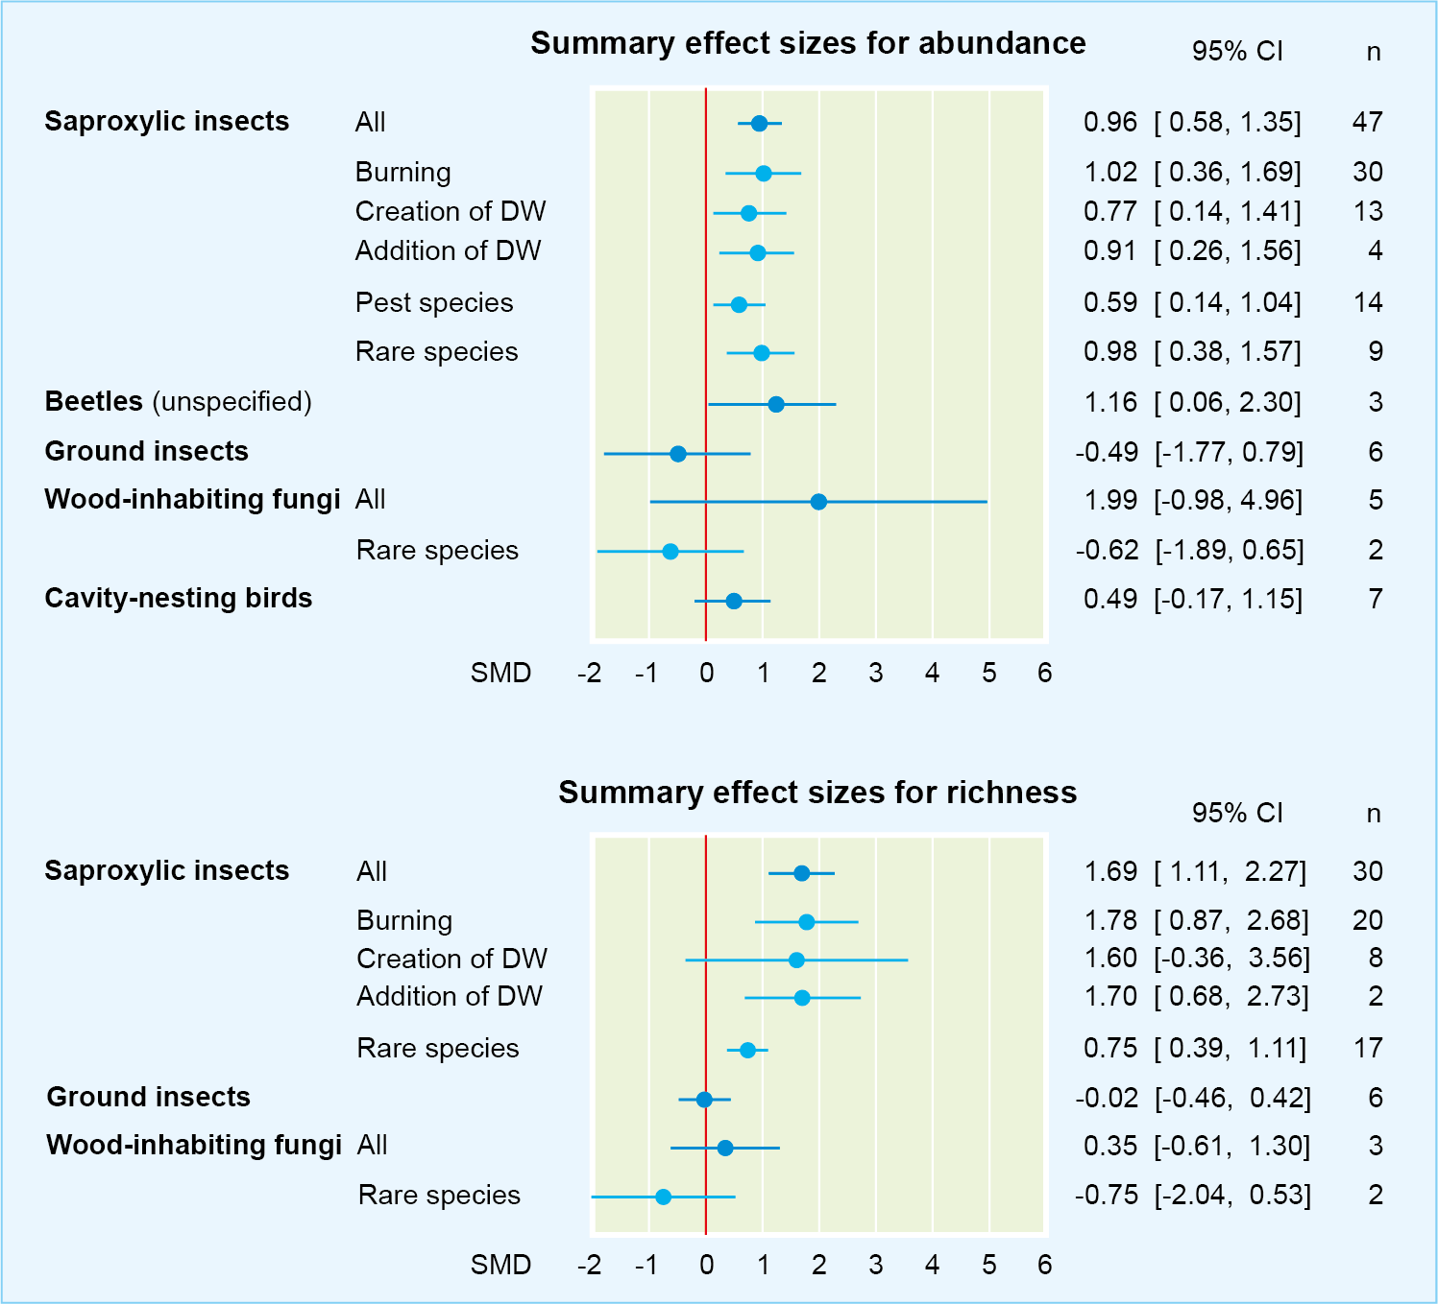
Figure A9-1. Responses of the abundance and richness of different taxon groups to dead-wood manipulation. Analyses were based on data from the first post-treatment year of sampling for each study – cf. Figure 2 in the main text, which is based on data from the final year of sampling.

Table A9-1. Average time elapsed since intervention.
Studies of abundance
 | First year of sampling |  | Final year of sampling |  | No. of studies
Taxon group | Mean (years) | SD | Mean (years) | SD | No. of studies
Saproxylic insects | 1.05 | 0.64 | 1.83 | 1.29 | 47
Saproxylic pest insects | 1.49 | 0.94 | 1.67 | 0.96 | 14
Rare saproxylic insects | 0.80 | 0.30 | 1.89 | 1.76 | 9
Beetles (unspecified) | 0.90 | 0.95 | 1.47 | 0.92 | 3
Ground insects | 3.33 | 2.88 | 4.00 | 2.37 | 6
Fungi | 1.68 | 1.87 | 7.00 | 8.49 | 5
Rare fungi | 0.70 | 0.42 | 13.00 | 12.73 | 2
Studies of species richness
 | First year of sampling |  | Final year of sampling |  | No. of studies
Taxon group | Mean (years) | SD | Mean (years) | SD | No. of studies
Saproxylic insects | 0.87 | 0.35 | 2.24 | 2.03 | 30
Rare saproxylic insects | 0.95 | 0.36 | 2.53 | 2.58 | 17
Ground insects | 3.00 | 3.10 | 4.00 | 2.37 | 6
Fungi | 2.13 | 2.50 | 10.33 | 10.12 | 3
Rare fungi | 0.70 | 0.42 | 13.00 | 12.73 | 2

Influence of individual experiments
Roughly half of the outcomes included in our meta-analyses derived from two large experiments in Finland (the EVO and FIRE studies; Eriksson et al. 2006, Heikkala et al. 2016a, Heikkala et al. 2016b, Hyvärinen et al. 2005, Hyvärinen et al. 2006, Hyvärinen et al. 2009, Junninen et al. 2008, Martikainen et al. 2006, Pentillä et al. 2013, Pitkänen et al. 2008, Toivanen & Kotiaho 2007, Toivanen et al. 2009, Toivanen & Kotiaho 2010, Toivanen et al. 2014). After having excluded all data from these two experiments, we repeated the analyses (where enough data remained) as a further check of the robustness of our findings. The abundance of saproxylic pest insects, which responded positively to dead-wood manipulation based on data from all available studies, showed no significant response when EVO and FIRE data were excluded (Table A9-2). Otherwise, exclusion of data from these two experiments did not affect the our results.

Table A9-2. Summary effect sizes with two big experiments (EVO and FIRE)
included or excluded
 | All studies included |  |  |  | EVO and FIRE studies excluded
 | SMD | 95% CI |  | n | SMD | 95% CI |  | n
Abundance | Mean | Low | High |  | Mean | Low | High
Saproxylic insects | 0.85 | 0.56 | 1.14 | 47 | 0.97 | 0.52 | 1.41 | 22
Saproxylic pest insects | 0.5 | 0.05 | 0.95 | 14 | 0.65 | -0.21 | 1.5 | 3
Beetles (unspecified) | 1.4 | 0.36 | 2.43 | 3 | 1.4 | 0.36 | 2.43 | 3
Ground insects | -0.67 | -1.94 | 0.6 | 6 | -0.13 | -1.07 | 0.81 | 4
Wood-inhabiting fungi | 2.75 | 1.44 | 4.05 | 5 | 3.38 | 2.54 | 4.23 | 3
Richness
Saproxylic insects | 1.74 | 0.69 | 2.24 | 30 | 2.12 | 0.51 | 3.72 | 14
Ground insects | -0.15 | -0.66 | 0.37 | 6 | -0.09 | -0.71 | 0.53 | 4

Studies where dead-wood amounts decreased
While interventions of the types covered by this review generally result in increased amounts of dead wood, a few of the included studies of burning reported that dead-wood amounts had decreased as a consequence of the fire. This applied to three of the seven studies of cavity-nesting birds that were included in our meta-analyses, whereas the amounts of dead wood had increased in the four other studies. The response to burning of bird abundance did not differ significantly between these two groups of studies (SMD: 0.69, CI: -0.27, 1.65, n=3 and SMD: 0.63, CI: -0.81, 2.07, n=4 in studies with decreased and increased amounts of dead wood, respectively). One case with lower dead-wood amounts after burning also appeared among the studies of saproxylic insect abundance (Apigian et al. 2006). Exclusion of this study made little difference to the average abundance response to prescribed burning (SMD: 1.04, CI 0.82, 1.48, n=29 with the study excluded; SMD: 0.99, CI: 0.84, 1.34, n=30 with the study included).

Publication bias

We tested for possible publication bias using funnel plots for the available data on saproxylic insect abundance and richness. Funnel plots are scatter plots of effect sizes against a measure of precision, usually the standard error. However, funnel plots that combine SMDs and standard errors are susceptible to distortions that could be interpreted as signs of publication bias even where no such bias is present. Therefore, we used the inverse square root of the sample size as a measure of precision in our funnel plots, as recommended by Zwetsloot et al. (2017). In the funnel plots, both abundance and richness data show some asymmetry suggesting the possibility of publication bias (Figure A9-2). The pattern indicates that studies with high precision (due to a large number of observations) generally reported effect sizes somewhat closer to zero than studies with lower precision.

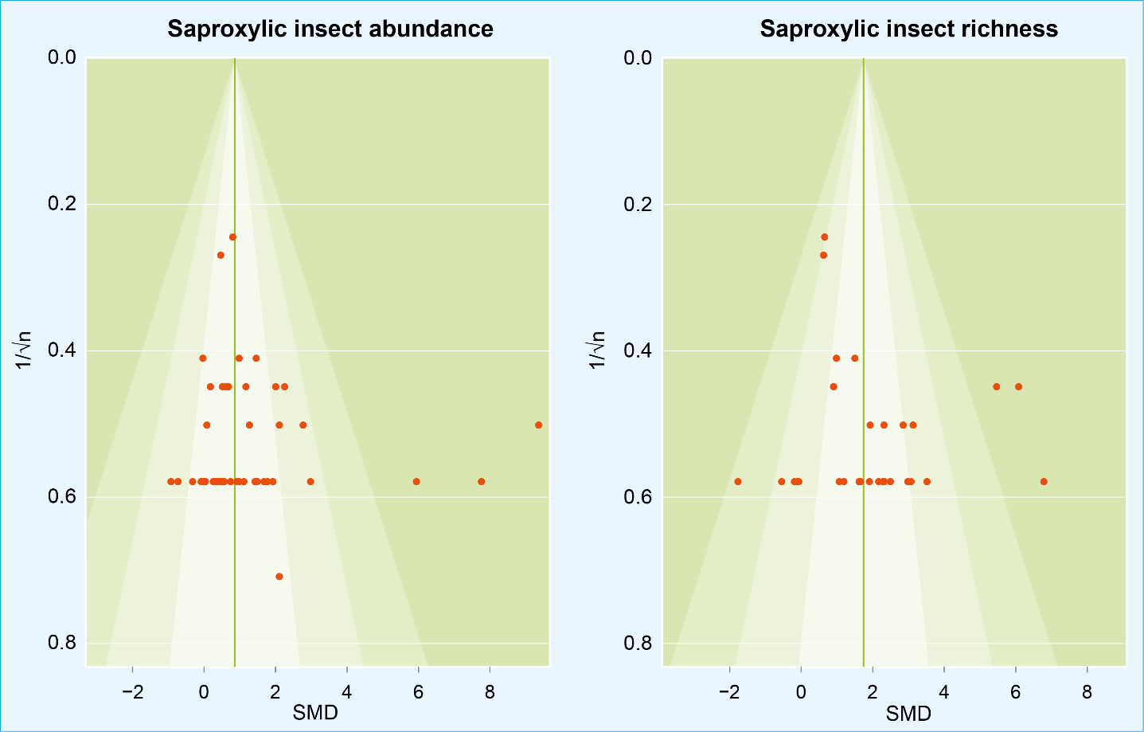
Figure A9-2. Funnel plots for responses of saproxylic insect abundance and richness to dead-wood manipulation. The inverse square root of the sample size is used as a measure of precision. Background shadings have been applied to facilitate comparison but have no particular significance.

We also calculated fail-safe numbers (Rosenthal 1979) for species groups with the highest numbers of comparisons (Table A9-3). The outcomes indicate that the results for saproxylic insects are robust, with fail-safe numbers well above threshold values suggested by Rosenthal (1979), but less robust for other species groups.
Table A9-3. Fail-safe numbers (Rosenthal)
 | Abundance |  | Richness
 | Rosenthal fail-safe number | 5n+10 | Rosenthal fail-safe number | 5n+10
Saproxylic insects | 1134 | 245 | 1059 | 160
Pest species | 26 | 80
Ground insects | 4 | 40 | 0 | 40
Wood-inhabiting fungi | 112 | 35 | 3 | 25

The fail-safe number refers to the number of missing studies with an average effect size of zero that have to be added to make the combined effect size insignificant (with a target significance level of 0.05). A threshold value (5n+10) smaller than the fail-safe number indicates a robust result.
References:

Apigian, K. O., Dahlsten, D. L., Stephens, S. L. (2006). Fire and fire surrogate treatment effects on leaf litter arthropods in a western Sierra Nevada mixed-conifer forest. Forest Ecology and Management, 221, 110-122.
Eriksson, M., Lilja, S., Roininen, H. (2006). Dead wood creation and restoration burning: Implications for bark beetles and beetle induced tree deaths. Forest ecology and management, 231, 205-213.
Heikkala, O., Martikainen, P., Kouki, J. (2016a). Decadal effects of emulating natural disturbances in forest management on saproxylic beetle assemblages. Biological Conservation, 194, 39-47.
Heikkala, O., Martikainen, P., Kouki, J. (2016b). Prescribed burning is an effective and quick method to conserve rare pyrophilous forest-dwelling flat bugs. Insect Conservation and Diversity, 10, 32-41.
Hyvärinen, E., Kouki, J., Martikainen, P., Lappalainen, H. (2005). Short-term effects of controlled burning and green-tree retention on beetle (Coleoptera) assemblages in managed boreal forests. Forest Ecology and Management, 212, 315-332.
Hyvärinen, E., Kouki, J., Martikainen, P. (2006). Fire and green-tree retention in conservation of red-listed and rare deadwood-dependent beetles in finnish boreal forests. Conservation Biology, 20, 1711-1719.
Hyvärinen, E., Kouki, J., Martikainen, P. (2009). Prescribed fires and retention trees help to conserve beetle diversity in managed boreal forests despite their transient negative effects on some beetle groups. Insect Conservation & Diversity, 2, 93-105.
Junninen, K., Kouki, J., Renvall, P. (2008). Restoration of natural legacies of fire in European boreal forests: an experimental approach to the effects on wood-decaying fungi. Canadian Journal of Forest Research, 38, 202-215.
Martikainen, P., Kouki, J., Heikkala, O., Hyvärinen, E., Lappalainen, H. (2006). Effects of green tree retention and prescribed burning on the crown damage caused by the pine shoot beetles (Tomicus spp.) in pine-dominated timber harvest areas. Journal of Applied Entomology, 130, 37-44.
Penttilä, R., Junninen, K., Punttila, P., Siitonen, J. (2013). Effects of forest restoration by fire on polypores depend strongly on time since disturbance - A case study from Finland based on a 23-year monitoring period. Forest Ecology and Management, 310, 508-516.
Pitkänen, A., Kouki, J., Viiri, H., Martikainen, P. (2008). Effects of controlled forest burning and intensity of timber harvesting on the occurrence of pine weevils, Hylobius spp., in regeneration areas. Forest Ecology and Management, 255, 522-529.
Rosenthal, R. (1979). The file drawer problem and tolerance for null results. Psychological Bulletin, 8 (2), 157-159.
Toivanen, T. & Kotiaho, J. S. (2007). Mimicking natural disturbances of boreal forests: The effects of controlled burning and creating dead wood on beetle diversity. Biodiversity and conservation, 16, 3193-3211.
Toivanen, T., Liikanen, V., Kotiaho, J. S. (2009). Effects of forest restoration treatments on the abundance of bark beetles in Norway spruce forests of southern Finland. Forest Ecology and Management, 257, 117-125.
Toivanen, T. & Kotiaho, J. S. (2010). The preferences of saproxylic beetle species for different dead wood types created in forest restoration treatments. Canadian Journal of forest Research, 40, 445-464.
Toivanen, T., Heikkilä, T., Koivula, M. J. (2014). Emulating natural disturbances in boreal Norway spruce forests: Effects on ground beetles (Coleoptera, Carabidae). Forest Ecology and Management, 314, 64-74.
Zwetsloot, P.-P., Van Der Naald, M., Sena, E., Howells, D., IntHout, J., De Groot, J., ... Wever, K. E. (2017). Standardized mean differences cause funnel plot distortion in publication bias assessments. eLife, 6(e24260). doi: 10.7554/eLife.24260

