Appendix 2. Full description of literature searches and screening
In our systematic map of how biodiversity is affected by various forms of active forest management, we included a total of 812 studies (Bernes et al. 2015). Of these, 276 were listed as describing effects of prescribed burning or creation/addition of dead wood and were therefore potentially eligible for inclusion in this review. Two of these studies were excluded since the interventions had been incorrectly categorised in the systematic map. Of the remaining 274 studies, 158 were excluded since their outcomes were not considered relevant to the review. Another 32 studies were excluded since they described effects of prescribed burning but did not provide quantitative estimates of how this intervention had changed the amounts of dead wood. This left 84 studies from the systematic map that were found to be relevant for this review (Figure A2-1). Each of the excluded articles is listed in Appendix 4 together with the reason for exclusion.
On 28 September 2016, Web of Science was searched for recently published literature on effects of dead-wood manipulation (Appendix 3). Of the 1,828 articles returned, 450 had already been identified when we searched for literature for the systematic map. Title screening of the remaining 1,378 articles left 584 articles considered as potentially relevant. After screening on abstracts, 48 of these articles remained. Full-text screening left 11 articles, one of which described two separate studies. Reasons for exclusion at full-text screening are provided in Appendix 4 and summarised in Table A2-1 below.

Reason for exclusion | No. of articles
Not a study of forests, woodlands or other terrestrial habitats with a tree layer | 1
Not a study made in boreal or temperate vegetation zones | 1
Not a field study | 1
Not a study of burning or creation/addition of dead wood | 15
No useful comparator data | 3
Not a study of outcomes relevant to this review | 14
Study of burning without quantitative data on changes of dead-wood amounts | 3
Full text not found | 1

Table A2-1. Reasons for exclusions at full-text screening of articles from the search update.
Two of the articles appear more than once in the table, since they were excluded for more than one reason.

On 5 October 2016, a search for recent literature using Google Scholar provided 3 relevant articles in addition to those that had already been identified, and one more relevant article was supplied by a member of the review team (Appendix 3). In all, therefore, we identified 99 articles (with 100 studies) as relevant to the review.

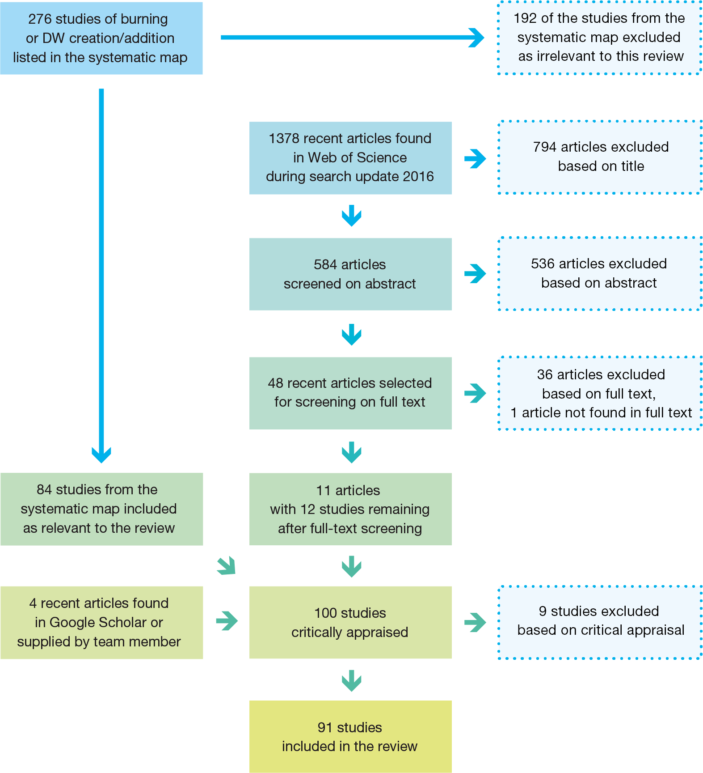
Figure A2-1. Overview of article inclusion and screening.
Reference
Bernes C, Jonsson BG, Junninen K, Lõhmus A, Macdonald E, Müller J, Sandström J. 2015. What is the impact of active management on biodiversity in forests set aside for conservation or restoration? A systematic map. Environmental Evidence, 4:25

